The Effect of Increased Access to Healthcare on Migrant Health Status in China

By Angela Petrone

Honors Economics Thesis

Boston College

**Objectives.** This paper looks at the recent healthcare reforms in China and analyzes the effects they have had on rural-to-urban migrants. Migration has increased over the last decade causing unprecedented inflows of rural residents to urban areas and has led to a wide range of public health concerns. The goal of this paper is to investigate whether increased access to healthcare for migrants would increase the population’s overall health status. In this paper, access to healthcare refers to health insurance coverage, proximity to and utilization of healthcare institutions, and the pricing of pharmaceuticals.

**Methods.** I will first analyze the migrant population in provinces with high migration rates to see what kinds of health problems and needs these people have. This will include estimating the total number of people who live in urban areas, since migrants are usually not officially documented due to the government-run household registration system (“*hukou* system”), as well as determining what kinds of services are available to them while living in urban areas. I will also investigate the impact of increased health insurance on the urban poor population, which resembles the migrant population, in these provinces and their utilization of hospitals, clinics, and pharmacies.

**Results.** The data suggest that there is a negative correlation between cost of care and rural-to-urban migrants seeking healthcare services. Therefore, lowering these costs would increase how much migrants utilize health services. However, surveys of migrants indicate that time and labor conditions are also significant factors in their ability to seek care, and so without decreasing work hours per week, decreasing healthcare costs will not improve health status as significantly as the Chinese government hopes. Additionally, since migrants tend to rely on over-the-counter drugs rather than prescriptions, they are not as sensitive to changes in prescription drug prices as the rest of the population. The results suggest that the current healthcare reforms in China will not significantly improve migrant health status unless labor conditions and health education are also improved.

**Introduction**

Starting in the 1940s, China began implementing a series of reforms to its healthcare system under the direction of Chairman Mao Zedong. Chairman Mao created a healthcare system that was sustained through heavy taxes, allowing Chinese citizens to receive medical care wherever and whenever they needed it at no additional cost (Reid, 2001). After Chairman Mao’s reign ended and China began to move away from its traditional centralized governing style, healthcare changed significantly. In recent years, healthcare has become much more privatized and many more changes are expected to follow in the coming years.

Additionally, in recent years, China’s gross domestic product (GDP) growth has exploded, increasing for many years at double digit percentage rates. During this time of incredible economic growth, improvement to the healthcare system has noticeably lagged. While the Chinese government currently reports that 95% of its citizens are covered by health insurance, there is evidence that the overall health of the countryhas not improved significantly over the last few decades. A national poll conducted in 2005 reported that the largest barriers to healthcare that citizens faced were lack of access and high cost (Eggleston, 2007). Additionally, there have been a number of reports from international news outlets like *The Economist* and the *New York Times* that doctors are overworked, undertrained and underpaid, and that many hospitals are not as safe as they should be (New York Times, 2010). The consequences of this have been long lines outside of clinics and hospitals and in some extreme cases, unhappy patients physically assaulting doctors over mistreatment or medical error (The New Yorker, 2014).

China has faced a number of unique challenges in its attempts to reform its healthcare system. Although it is a country that is heavily involved in international commerce, China is still considered to be a developing nation with more than 40% of the population living in rural areas and relying on agriculture to survive (CIA World Factbook, 2011). These areas, mostly concentrated in the middle of the country, are remote and are made up of people who subsist on much lower annual income than their urban counterparts (Figure 1). For this reason, a major goal of recent reforms has been to improve access to modern medicine to these residents. However, given the poor conditions of these rural areas, many residents have chosen to migrate from their homes to the cities in China.

Despite the high levels of rural-to-urban migration (Table 1), healthcare reforms have not been aimed at this growing population. Therefore, the goal of this paper is to study the healthcare needs of the rural-to-urban migrant population in an effort to determine if the current reforms will improve their overall health status. Evaluating the health status of this group is challenging because rural-to-urban migrants are officially registered with the government as rural citizens, even after they migrate to a city. This is due to the household registration (*hukou*) system which was put in place to prevent overcrowding in China’s already extremely populous cities. The combination of these factors makes it difficult to accurately estimate how many rural-to-urban migrants are in China’s cities because of the widespread underreporting of illegal residency. Despite these challenges, it is evident that this problem must be addressed because improving the health of this growing migrant population is a key part of protecting China’s overall public and economic health.

*The Rural-to-Urban Migrant Population*

In order to better understand the health needs of the rural-to-urban migrants, it is important to understand what kinds of people make up this population. The migrant population has continued to grow, and while the Chinese government has estimated that the population is to approximately 230 million, others estimate it is closer to 245 million (China Statistical Yearbook, 2013). This growing population has become a crucial part of China’s manufacturing and construction sectors, and therefore, it is essential for China’s economy that the health status of migrants increases. These data are not accurately captured by government census surveys because rural-to-urban migrants do not have urban *hukous* and are usually not officially employed. Therefore, they are not counted by the government, much like illegal immigrants in the United States. Universities and research organizations in China and around the world have made an effort to estimate the numbers of rural-to-urban migrants and determine their health needs.

**The Current Status of Healthcare in China**

In 2013, the newly created Chinese Commission of Health and Family Planning estimated that there were currently about 7.3 billion hospital visits spread over 974,000 healthcare institutions (Bin, 2014). While the number of hospitals has increased, the overall number of healthcare institutions has fluctuated nationwide and in provinces with high inflows of migrants over the last decade (China Statistical Yearbook, 2014). To put China’s reforms in perspective, during this time, China was spending about $445.5 billion USD annually on healthcare which was 5.4% of their GDP, compared to the $2.809 trillion USD annually, or 17.9% of GDP, spent by the United States (Bin, 2014). This is an important comparison because in 2013, both nations were quickly moving towards universal health coverage and, although China has more than four times the population of the United States,US spending was greater than six times more than healthcare spending in China. However, in 2013 the Chinese government has reported that 95% of the 1.3 billion Chinese citizens have access to basic medical insurance systems compared to the approximately 85% of Americans covered in the same year (US Census Data, 2013).

In China, citizens can qualify for one of three kinds of health insurance plans: Urban Employee Basic Medical Insurance (UEBMI), Urban Residential Medical Insurance (URMI), or the Rural Cooperative Medical Scheme (RCMS) which is also referred to as the New Cooperative Medical System (NCMS). Health insurance coverage has become continuously more widespread since 2007 when the URMI was implemented (Lin et al., 2009). As the name indicates, UEBMI is health insurance for citizens who legally live in urban areas (i.e. have an urban *hukou*) and are officially employed. However, the UEBMI leaves out Chinese citizens who legally live in urban areas but are unemployed. For this reason, the Chinese government decided to implement the URMI in stages, starting in 2007. By the end of 2008, citizens in half of China’s cities had the option to be covered by URMI (Lin et al., 2009). The government’s goal was to try to close the insurance coverage gap between citizens who qualified for URMI but not UEBMI, and in turn extended URMI coverage to all of China’s cities in 2010 (Lin et al., 2009).

To complete medical insurance coverage for Chinese citizens, the government created the RCMS. This final component of China’s healthcare program is available to rural residents who have a rural *hukou* and aims to provide them with better care than has been available to them in the past. There are a lot of opportunities to improve healthcare to residents in rural areas because previously, the only healthcare professionals who served these areas were “barefoot doctors.” These doctors, although able to reach remote parts of the population, were severely limited in their ability to provide quality care due to the fact that they were constantly traveling. This meant that, although residents could receive medical advice from primary care physicians, they still had to travel many miles to get to facilities that had imaging and testing equipment, such as X-rays or ultrasound machines**.**

Today, part of the reforms and the continued development of the RCMS are aimed at bringing this technology closer to rural residents through new mobile technology and applications. A key innovation that China has begun to support is the use of telemedicine, which helps provide rural citizens with access to primary care physicians and specialists who can better diagnose specific conditions. In addition, Chinese health commissions are working to set up at least one health clinic in every village that is no more than 15 minutes away from all citizens living in the area (Bin, 2014). However, implementing these reforms and building the infrastructure needed to achieve these healthcare goals is expensive which has caused progress to be slow and has in part contributed to citizens leaving their homes in the center of the country for China’s coastal cities (Figure 2; Table 1).

The government’s attention to reforming healthcare in rural areas is much needed, but since the majority of the population now resides in urban areas, China’s heavily populated cities have become the cause of concern for advocates of public health. Even without considering the rising rates of pollution in northern cities such as Beijing, the sheer number of people living in these areas puts China at risk for problems like the quick spread of infectious diseases, as was seen in 2002 and 2003 with the severe acute respiratory syndrome (SARS) outbreak.

In recent years, the high levels of rural-to-urban migration have exacerbated these problems. The migrant population has grown from 50 million in 1990 to 236 million in 2012, with the majority of migrants moving from rural to urban areas (Fang, 2014; China Statistical Yearbook, 2013). While such a drastic increase may in part be a result of authorities getting better at counting migrants, the simultaneous increase of migrant-populated make-shift villages on the outskirts of Chinese cities indicates that the migrant population is growing (Park and Wang, 2010). Additionally, the number of rural migrants moving into the cities to seek work has intensified the overcrowding problems within the Chinese hospital system. Therefore, while moving forward with the current healthcare reforms, it is important for the Chinese government to consider not only the current rural populations who continue to live in the middle of the country, but also to develop healthcare policy that serves rural-to-urban migrants who have been left out of the reforms thus far.

In addition to these problems with healthcare reform, a unique aspect of developing Chinese public health is the clash of eastern and western cultures. While there has been a trend in urban areas for western-style hospitals and treatments like the United Family Healthcare Hospitals and Clinics, rural residents have continued to use eastern remedies and medicinal methods. Some argue that these methods are outdated; however, others feel that there is no real reason to eschew them after thousands of years of use. Some health insurance carriers continue to cover eastern methods, such as acupuncture, herbal medicine and Tai Chi classes, in their plans. Rural-to-urban migration has highlighted how different these medicinal methods are, as more traditional-minded Chinese citizens flow into China’s much more modern cities.

In addition to eastern and western coverage plans and medicinal practices, China’s health system has an emergency care policy that states that patients in need of emergency care must be treated immediately and then charged for care later. This policy helps to protect Chinese citizens who are in dire need of medical help; however, it does put the burden of cost on the hospital system if the citizen is ultimately unable to pay the bill. Emergency situations can range from urgent bodily injuries sustained at work to strokes, heart attacks, and other catastrophic health problems. In fact, the major causes of death in China among the entire population are heart and lung problems, specifically hypertension, cerebrovascular disease, and diseases of the respiratory system (China Statistical Yearbook, 2013). Causes of these are excessive stress, unhealthy diets that consist of a lot of sodium, fats and carbs and little fruits and vegetables, and smoking. Malignant tumors (i.e. cancer) are also a leading cause of death; however, cancer treatments and cures are expensive and still largely unavailable to the urban poor and migrants.

Even in cases where a patient does have medical insurance, the reimbursement policy is not always enough and the majority of the bill falls on the hospital system (Bin, 2014). The government considers healthcare to be a social good and covers the essential and basic level of healthcare while other forms of care is subsidized. For example, the government has also reduced the price of 520 types of drugs by about 30% in the last few years (Bin, 2014). However, despite the efforts of the Chinese government to lower costs, healthcare is still expensive and, in many cases, low quality. This task is particularly important for the health of rural-to-urban migrants who live off of low incomes and are susceptible to a myriad of health problems. Therefore, focusing on the prevention of health problems that affect migrants, such as heart and lung disease, are cost-effective ways of lowering the overall death rate and increasing the health status of rural-to-urban migrants.

**Quality of Care and Obstacles to Achieving It**

While aiming for universal healthcare has been the goal of the Chinese government, it is important to consider that universal coverage is not the same as quality coverage. The National Health Service in the United Kingdom has defined quality care as healthcare that is effective, accessible and timely, safe, patient centered, equal to all patients, and low patient to doctor ratios (QQUIP, 2009). The UK has been regarded as a model for effective universal, quality healthcare and has created a comprehensive healthcare constitution that outlines its policies; however, China’s healthcare system as fallen short of these standards. The top quality care issues in China are (a) Multi-drug resistance (b) Irrational use of medicines and medical procedures (c) Lack of drug quality, safety and adverse drug reactions monitoring (d) Lack of proper hospital accreditation, and (e) Medical errors (Hu, 2011).

Multi-drug resistance can occur when doctors prescribe too many of one kind of drug and is most commonly seen in the overuse of antibiotics. Over-prescription of antibiotics can occur when doctors do not know the cause of a patient’s illness or when there are cost incentives for them to prescribe a certain drug. This leads patients to develop a resistance to antibiotics, which is very problematic if they get an infection and need antibiotics to fight an infection. Similarly, the overuse of medical procedures can occur when either a doctor does not know how to properly treat a patient or if the hospital stands to gain monetarily from mistreating the patient. For example, if a patient with a cold sees a doctor, the doctor could either recommend that the patient drink some fluids, go home and rest. This treatment results in minimal profit for the doctor or the hospital. However, if the doctor instead chooses to run a series of tests on the patient, knowing that the cost will be covered either by insurance or the patient, the hospital and the doctor can make a significant amount of money. Unfortunately, this is not an infrequent occurrence in Chinese hospitals.

Along with making sure hospitals are acting in the interest of the patient and not their bottom lines, the Chinese government has also made efforts to bring all hospitals up to standard, focusing on promoting patient safety and welfare as well as the overall quality of medical service provided (Hu, 2011). A key component of hospital accreditation and quality care is the minimization of medical errors. Part of current healthcare reforms includes having a more rigorous training program for doctors. Recently, China has set up a new training mechanism where different kinds of healthcare professionals are separately trained according to different healthcare needs. The three major categories are nurses, who are trained to perform basic medical tasks, doctors, who can either be primary care physicians or specialists; and rural doctors, who are trained to best serve the specific needs of the rural population. This new training mechanism consists of five years of medical school, three years of residency, and at least three more years of specialty training, if needed (Bin, 2014).

While these strategies may be effective in the next 10 to 15 years, they do not immediately help the current need for more doctors in China. Therefore, it is crucial that the Chinese government develops a way to incentivize more people to become doctors in order to accommodate the large amount of patients medical professionals see every day. Some studies show that an effective way to do this is to increase the wages of healthcare professionals (Qin et al., 2013); however, doing so would increase the overall cost of medical care. It is also important that the Chinese government prioritize quality healthcare in its reforms, putting particular emphasis on these major issues, in order to improve the overall health of the Chinese population.

Finally, a major obstacle to developing more comprehensive, effective policy in China that promotes universal quality care is their disjointed political system. With so many different ministries and commissions, it is not uncommon for different administrators, particularly on the provincial level, to simultaneously develop conflicting policy or work on the same policy in different ways without coordination (Bin, 2014). Reforms are also in place to change the way government officials work on policy; however, with the major healthcare reforms already underway, it is unclear as to when the political reforms will actually be effective.

Therefore, quality care must not only be available at affordable costs, but rural-to-urban migrants must also live in the vicinity of quality healthcare institutions, such as hospitals, legal clinics, and pharmacies. Because of the *hukou* system, migrants have health insurance that is only effective when they are in their home province (usually only a few times a year). This means that migrants typically cannot afford to go to local hospitals or take prescribed medication (Hong, et al., 2006). Instead, migrant workers are much more likely to purchase over-the-counter medications, go to cheap urban clinics, and practice home remedies to cure their ailments while living in urban areas (Hong, et al., 2006).

**The *Hukou* System**

The *hukou* system has created a number of obstacles for rural-to-urban migrants to receive basic social goods. The purpose of the *hukou* system is to curb over-population in China’s already crowded cities (Eggleston, 2007). However, this has caused many problems for the growing migrant population, such as discrimination (Shi, 2008) and not getting access to basic necessities, like clean water, proper housing, or basic healthcare (Chan, 2013). The *hukou* system particularly presents problems for migrants as it does not allow non-urbanites to access hospitals or doctors in urban areas where migrants go for extended periods of time to seek work. The only exceptions are migrants who have actual employee contracts (because they would then qualify for UEBMI), but this is rare. This puts migrants in the position of having to choose between applying for an urban permit and receiving access to social goods like housing and healthcare, or having their agricultural land back home. Additionally, migrants move back and forth irregularly between their rural homes and neighboring cities, which means that their children are left on their own or raised by grandparents who are usually uneducated. Therefore, these children, who are future migrants, are not well educated, especially regarding Western healthcare which exacerbates the rural-to-urban migrant health problem. Since very few migrants are willing to give up their land in their home province because it is still a significant part of their income, most migrants end up living in cities in poor conditions for years (The Economist, 2013) while family members in their home province manage their land.

Similarly, because getting an urban *hukou* takes time and is often not appealing to migrants for financial and personal reasons, migrants are often forced to work without proper employee contracts that would provide them with health insurance. It also means that migrant workers tend to do more dangerous jobs and tasks that urban citizens avoid. Since Chinese hospitals are not allowed to turn away patients who are suffering from catastrophic medical problems, (i.e. broken bones, severed limbs, etc.) migrants injured on the job are filling emergency room beds without paying into the system. According to a 2008 report conducted by the NIH, 47% of migrants were “unwilling to make contributions to health insurance” (Public Health Reports, 2008). This unwillingness also worsens the problem by increasing the number of people who need health services but decreasing the amount of resources per person available.

**Literature Review**

The study of China’s rural-to-urban migrant population presents a specific challenge: the inaccuracy of government census data, where individuals are counted based on their *hukou* status rather than where they live most of the year. Therefore, researchers have conducted a number of surveys targeted at specific parts of the population to collect more accurate information. Hesketh et al. (2008) designed a survey aimed at determining health status and access to health care for migrants. They sampled 1,958 urban workers, 1,909 rural workers, and 4,452 migrant workers and compared their responses about their occupations, age, and marital status as well as working hours per day and week, monthly salary, health insurance, types of disabilities and chronic diseases, and health status. The study concluded that migrants tend to report that they are healthier than other parts of the population.

This study determined that rural-to-urban migrants were generally young and worked very long hours, with almost a third working more than 12 hours per day and 81% working six or seven days a week, often in dangerous conditions. Despite this, the study found that rural-to-urban migrants displayed the “healthy migrant effect” (Hesketh et al., 2008), meaning that 99% of the migrants surveyed reported their health as either “excellent or very good” or “good/OK.” This was higher than both permanent rural residents, who reported the same health status at a rate of 94%, and permanent urban residents, who reported having excellent, very good, good, or OK health at a rate of 98%. It is difficult to determine whether this is due to a selection bias (i.e. the migrant population is made up of people who are able to actually migrate and work long hours most days of the year) or if migrants simply self-report a better health status than their rural and urban counterparts with the same objective health status.

In another study, Hong et al. (2006) explored this “healthy migrant effect” in their paper *Too Costly to be Ill*. Their study was based on interviews with 90 rural-to-urban migrants about their access to healthcare and health-seeking behavior. This study offered important insight into the lives of rural-to-urban migrants because the researchers physically engaged in conversation with migrants, rather than have them fill out a survey with a series of questions. They found that care at Chinese hospitals costs significantly more than care at clinics, and that the high cost is a deterrent for migrants to seek healthcare from hospitals. This is problematic because, according to one participant in the study, there are much less stringent rules and regulations for clinics and the care offered there is much worse than hospital care.

Dumoulin-Smith (2005) reported a similar finding in his paper on social health insurance in China. Not only do urban clinics provide noticeably inferior care than hospitals, a number of illegal clinics have appeared in urban areas (Dumoulin-Smith, 2005). These clinics offer health services at a much cheaper rate than hospitals but do not necessarily maintain the same attention to safety, which has resulted in the deaths of some migrants (Dumoulin-Smith, 2005). These studies indicate that, while there may be a selection bias in the rural-to-urban population, cost of care directly affects the decisions migrants make about their health.

Another study conducted in 2012 by Zhao et al. looked at migrant health insurance coverage and how it affects the cost of medical care of the entire population. After surveying 644 migrant workers, the study found that, although the majority of participants were covered by health insurance plans in their rural home provinces, very few had insurance in the urban provinces in which they spent most of their time (Zhao et al., 2014). Additionally, the study noted that there is significant inequality in the distribution of health insurance resources between men and women because female migrants tend to be less educated, younger, and lower paid, which causes them to pay more of their healthcare expenditures out-of-pocket (Mou et al., 2009). Furthermore, the survey showed that healthcare costs for females tended to be higher than males and that these costs increased with age and prevalence of chronic illness for both genders (Zhao et al., 2014). It is also important to note that migrant workers send significant portions of their income back to their families in rural areas. Therefore, their total income does not accurately represent how much money migrants actually have to spend on themselves which explains why the study found only a slight correlation between healthcare spending and personal income (Zhao et al., 2014).

Zhao et al. (2014) found that insurance coverage, both by rural and urban plans, was lower in the migrant population than what the central government reported for the whole population. While there is no doubt that working to increase comprehensive health insurance coverage and decrease the overall cost of healthcare would improve access to healthcare for migrants at least a little, this study makes some key points about other factors that should also be considered, such as controlling for specific illnesses common among rural-to-urban migrants. Although it is difficult to collect data on what diseases are most prevalent in the migrant population due to their infrequent doctors’ visits, some studies have honed in on silent conditions and their impact on this population.

For example, Fang (2014) discussed the growing prevalence of hypertension in the Chinese migrant population and the mismanagement of this condition among rural-to-urban migrants. Hypertension is a chronic condition that needs to be closely monitored and managed through proper diet and medication. Decreasing hypertension and improving the management of it in all populations is critical for promoting the overall health of the population. Therefore, in order to accommodate the health needs of the growing rural-to-migrant population, new policies are needed to incentivize rural-to-urban migrants to seek regular medical care. Similarly, an important part of encouraging preventative care is making insurance plans and healthcare coverage more transferrable across geographic regions (Fang, 2014).

A study by Peng et al. (2010) found that, of the almost 3000 migrants survey in Beijing, respondents were most likely to avoid seeking care because they felt that they were not sick enough (Table 2). Additionally, the survey found that clinics and community health centers were much more popular for migrants than township of district-level hospitals (Table 3). Peng et al. (2008) determined that the healthcare system does not encourage rural-to-urban migrants to seek healthcare at high quality institutions and that reforms should include increased investment in medical services specifically for migrants. This study also concluded that migrants need better health education in order to be informed about their own needs and how to care for them.

Despite evidence that migrants report having better overall health status than other parts of the population, it is important to understand that this does not mean that they are healthier or that the health of the migrant population does not need to be improved. Inequality between classes is incredibly prevalent, particularly in healthcare, housing, wages, and other social services (Taylor, 2011).Migrants are not only limited by the high financial cost of healthcare, but also by the small amount of time during the week when they are not working. Since migrants typically work six or seven days of the week and approximately twelve hours each day (Hesketh, et al., 2008), they cannot afford to take a few hours to seek medical care. Therefore, time as well as cost is a limiting factor for improving the health status of rural-to-urban migrants that may not be able to be solved by the current health reforms in China.

**Data Availability**

Collecting data on migrant workers has been the goal of many economic researchers over the last few decades as health and healthcare have grown in importance. Therefore, the data in this paper on the health and spending habits of migrants is a synthesis of numerous studies done by researchers from all over the world. These studies, which tend to be conducted in specific regions with a few thousand participants, provide great detail about the distinct purchasing habits, healthcare needs, and health status of migrants. The personal nature of these studies, especially the ones that conduct one-on-one interviews, offer insight into migrant life that is crucial to understanding this population’s health problems and needs and help to develop policy that better addresses them. By combining the data and findings of each of these studies, this paper offers a more representative look at the migrant population as a whole, rather than the small, segmented results of the individual study.

In conjunction with these studies, this paper considers data on healthcare institutions, the work force, national prevalence of diseases, population growth and change, numbers of doctors, and welfare. These data come from national surveys conducted each year by the Chinese government that make up the China Statistical Yearbook. These annual data collections include more than two decades of data about numerous aspects of Chinese life. Many of the studies referenced in this paper rely on data from this Yearbook as it provides a large scale look at many different factors of the whole Chinese population over a large period of time. Unfortunately, the only data about migrants that the Yearbook provides is the estimated floating population. Since residing in an area without the proper *hukou* is illegal, it is unlikely that migrants would be willing to give much, if any, information to government workers collecting data. This reinforces the importance of the independent surveys conducted by researchers unaffiliated with the Chinese government.

Although the total population number is reasonably correct, census data based on *hukous* underestimate the number of people living in urban areas which is problematic for the government when trying to allocate social services. Similarly, people living in urban areas have much different daily lives than those living in rural areas and therefore, data on migrants pertaining to their specific habits and health status must be collected in specific surveys. Therefore, to supplement the general population data referred to in this paper, additional data comes from surveys conducted and published by other organizations.

These types of surveys are a useful source of more personal, qualitative data because they are not conducted by the government, but instead by people focusing specifically on the health status of migrants. As such, they tend to include quotes and personal statements from migrants about their health and healthcare spending habits. I used these data to investigate trends in healthcare spending and reforms and their impact in China’s urban poor in my targeted provinces. Although China’s urban poor population is not identical to the migrant population, they face similar financial, employment, and health problems. Also, the urban poor population is well documented and included in census data and therefore much easier to study. Therefore, the goal of this paper is to synthesize research done by a number of separate groups to create a more cohesive depiction of the health problems of migrants.

**Conclusion**

Studies show that migrants self-report a better health status than other populations for a number of reasons (Hesketh, et al, 2008). For one, migrants may be more likely to ignore health problems than other populations because they need to work so much. Another possibility is that they are generally unaware of their health problems because they are less likely to go see a doctor. Although ailments like gastrointestinal problems are easily detectable, silent conditions like hypertension, which is common among the entire Chinese population, cannot be diagnosed without regular doctors’ visits and blood pressure checks. Therefore, despite the “healthy migrant effect,” without ensuring that rural-to-urban migrants have access to regular quality care, it is difficult to get an accurate picture of the health of the population.

While there is no comprehensive survey of the entire migrant population, spot sampling shows patterns among migrants in different provinces that indicate rural-to-urban migrants are less likely to get prescription drugs but are very likely to purchase over-the-counter drugs (Hong et al., 2006). For this reason, it is unlikely that migrant health status would be significantly affected by a decrease in prescription drug pricing. Also, while decreasing the price of over-the-counter drugs would increase their accessibility to migrants, medications for conditions like high blood pressure and hypertension are rarely available over-the counter, and thereforeit is unlikely that the decrease in price would have a positive effect on migrant health status.

*Vulnerable Subpopulations*

*The Impact of Reform on Women’s Health*

Lack of health education is particularly concerning amongst migrant females. Although healthcare reforms have in part been aimed at improving access to gynecological and obstetric services to women by lowering cost of care and increasing health insurance coverage, social and cultural barriers have prevented migrants from getting the help they need. The patriarchal nature of Chinese society has created a heavy stigma surrounding reproductive health, especially among young women who make up a significant part of China’s floating population. The maintenance of good reproductive health is not limited to the prevention of disease and infection. It also includes the availability of safe means of fertility regulation, the capability to safely conceive and give birth, and the ability to decide when and how much to reproduce (World Health Organization, 2015). Using this definition, the data show that migrant women have poor reproductive health due to a lack of education, the social taboos around reproduction, and because they are often not aware of their rights as workers.

A 2013 survey conducted in Chong Qing found that migrant women are extremely unlikely to get regular gynecological exams (Su et al., 2014). Additionally, migrant women avoid going to see healthcare professionals about their reproductive health unless they are in extreme pain (Su et al., 2014). Another study conducted in Hunchun had similar findings. Not only were women unlikely to regularly consult medical professionals about their reproductive health, but they reported being embarrassed about the possibility of getting a gynecological exam from a male doctor (Li et al., 2010). Although this is not an uncommon feeling among women in general, embarrassment and modesty significantly deter Chinese women from seeking medical attention regarding their reproductive health. This mentality of not regularly visiting the doctor follows that of the general floating population; however, the repercussions of poor reproductive health and education have a direct impact on the next generation of China’s working class.

Due to the introduction of the one child policy in China, elective abortion rates have been very high among Chinese women. Even with the recent relaxation of the policy, women are still getting abortions but are unaware of many of the health risks associated with them (Su et al., 2014; Li et al., 2010).The data show that there is a positive correlation between years of schooling, income level, and knowledge of reproductive health; however most migrant women are not highly educated and receive very low wages (Jiang et al., 2010). Another reason for the high rate of pregnancies and abortions is a lack of cooperation from husbands and boyfriends who are not always receptive to the use of birth control (Wiebe et al., 2006; Su et al., 2014). The lack of control women have over their reproductive health has created a serious public health problem, particularly in the continuously increasing migrant population. Due to the social and cultural natures of this problem, the current healthcare reforms aimed at lowering healthcare costs will not be very effective in increasing the overall health status of this vulnerable population. Instead, policymakers should work to improve female and reproductive health education in China, particularly in rural and low-income urban areas in order to target future and current migrants. Destigmatizing reproductive health and increasing the number of safe sexual encounters will not only improve the lives of female migrants, but also slow the spread of sexually transmitted diseases.

Due to the poor conditions in which many migrants live, good personal hygiene, including regularly showering and wearing clean clothes, is rare. Additionally, women raised in rural areas are already at a disadvantage when it comes to health education compared to urban women. This is because of the prevalence of traditional medicinal methods and self-medication that is relied on by non-urbanites. The combination of these factors has adversely impacted reproductive health of rural-to-urban migrant females and has led to significantly higher morbidity rates due to reproductive tract infections in this population compared to their low-income urban counterparts (Su et al., 2014).

**Discussion**

Overall, migrants echo some of the same problems faced by the rest of the Chinese population. Specifically, migrants feel that getting medical care is difficult and expensive (Eggleston, 2008). However, it is evident that reducing the cost of healthcare and improving health insurance coverage will not necessarily promote better health among migrants. Therefore, the current reforms that are being implemented by the Chinese government are not likely to be very effective on the rural-to-migrant population. This is a significant problem for China, since these migrants make up a large percentage of the population and are largely responsible for China’s economic success in low-cost manufacturing. Without better attending to the specific needs of rural-to-urban migrants, including continuing reforms to the *hukou* system, China will be faced with a growing public health crisis.

Additionally, China’s recent emphasis on increasing its GDP at unprecedented rates while attempting to reform its healthcare system have had conflicting effects on public health. Therefore, China may also consider implementing labor reforms in conjunction with the ongoing healthcare reforms, since even with increased access to care, migrants who work more than ten hours a day, six days a week, in poorly maintained facilities are not going to get healthier.Similarly, the growing amount of pollution in many well-populated cities has resulted in rising rates of cancer while overpopulation and overcrowding have assisted the spread of communicable disease and infection.China must consider sacrificing some of its growth for the sake of the health of its workers, particularly rural-to-urban migrants who show no sign of permanently returning to their farms in the central part of the country.

Due to the one-child legislation, China has an aging society that has put even more pressure on the healthcare system. Additionally, with the growing number of migrants, more and more children in rural areas are being raised by their grandparents, who are much more likely to rely on traditional medicine to treat sickness than western medicine. Presumably, many of these children will become migrants themselves one day and without a basic understanding of preventative care will be less likely to live long, healthy, productive lives than their peers in other countries. This will continue to cripple the health of China’s population, especially since the number of rural-to-urban migrants is expected to keep increasing in the coming decades. Therefore, without addressing the health education needs of children in rural areas and more cost-effective ways of treating the growing number of Chinese citizens over the age of 65, China will not be able to sustain its already weak healthcare system.

Since increased health insurance coverage has been linked with increased healthcare institution usage, new policies aimed at widening coverage to vulnerable populations could worsen the problem of overcrowding in hospitals. Therefore, more targeted coverage for diseases and conditions that affect the migrant population would be a more efficient way to improve the overall health status of migrants. The most pressing health problems facing the whole population are silent, chronic conditions like hypertension, cerebrovascular disease, and cancer. Additionally, better reproductive education and care is needed to improve the health status of migrant women and children. Finally, anticipating the rising costs of care associated with having an aging population will help shift some of the financial burden off of migrants who send significant portions of their income back home to their families.

Both economic and labor reforms must be implemented in conjunction with the ongoing healthcare reforms to improve the living standards of rural-to-urban migrants. Closing the rural and urban income gap could help to disincentive the large-scale migration that has been taking place; however, this would be a challenging undertaking for a nation with such a profitable manufacturing industry. Expanding the manufacturing industry into rural areas could alleviate this problem; however, the environmental implications could prove to be highly problematic. Therefore, improving working conditions in highly populated cities and creating stricter regulations on how companies treat their employees could greatly increase health outcomes especially for rural-to-urban migrants.

Although this paper does not include any new data, synthesizing current research is an important step in trying to understand the healthcare needs of the rural-to-urban migrant population. By gaining a better understanding of what independent researchers found in a variety of provinces in China, new, less redundant research can be done in the future that more effectively illustrate the migrant population as a whole and how new healthcare policies can improve their health status. Hopefully, international interest in and concern for this population will continue to grow and ultimately improve the lives of rural-to-urban migrants in China.

**Appendix**

***Figure 1***

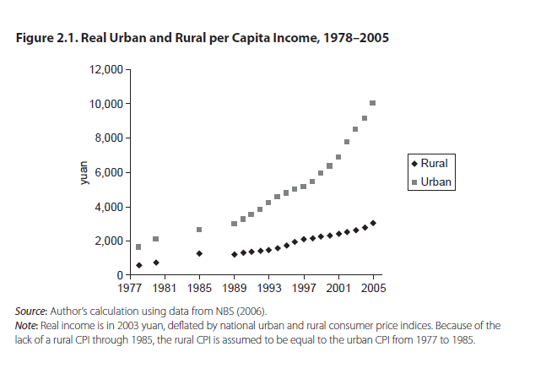

*Source:*

Park, Albert. “Rural-Urban Inequality in China.” Prepared for the Eleventh Five-Year

Plan of China. World Bank, Washington, DC., 2004.

***Figure 2***

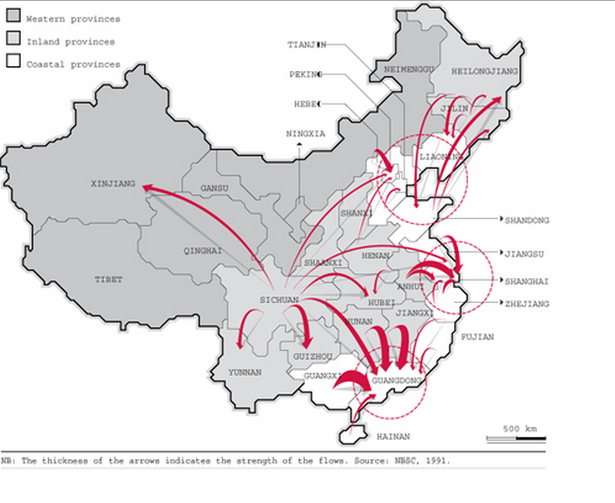

***Table 1***

|  |  |  |  |  |  |  |  |  |  |  |  |  |  |  |  |  |  |  |  |  |  |  |  |  |  |  |  |  |  |  |  |  |  |  |  |  |  |  |  |  |  |  |  |  |  |  |  |  |  |  |  |  |  |  |  |  |  |  |  |  |  |  |  |  |
| --- | --- | --- | --- | --- | --- | --- | --- | --- | --- | --- | --- | --- | --- | --- | --- | --- | --- | --- | --- | --- | --- | --- | --- | --- | --- | --- | --- | --- | --- | --- | --- | --- | --- | --- | --- | --- | --- | --- | --- | --- | --- | --- | --- | --- | --- | --- | --- | --- | --- | --- | --- | --- | --- | --- | --- | --- | --- | --- | --- | --- | --- | --- | --- | --- |
| |  |  |  |  |  | | --- | --- | --- | --- | --- | | **Year** | **Urban regions** |  | **Rural regions** |  | | 2002 | 502.12 |  | 782.41 |  | | 2003 | 523.76 | 4.30% | 768.51 | -1.78% | | 2004 | 542.83 | 3.51% | 757.05 | -1.49% | | 2005 | 562.12 | 3.55% | 745.44 | -1.53% | | 2006 | 582.88 | 3.69% | 731.60 | -1.86% | | 2007 | 606.33 | 4.02% | 714.96 | -2.27% | | 2008 | 624.03 | 2.92% | 703.99 | -1.53% | | 2009 | 645.12 | 3.38% | 689.38 | -2.08% | | 2010 | 669.78 | 3.82% | 671.13 | -2.65% | | 2011 | 690.79 | 3.14% | 656.56 | -2.17% | | 2012 | 711.82 | 3.04% | 642.22 | -2.18% | |  |  |  |  |

*Urban and rural population of China from 2002 to 2012 (in million inhabitants)*

Source: China Statistical Yearbook

***Table 2***

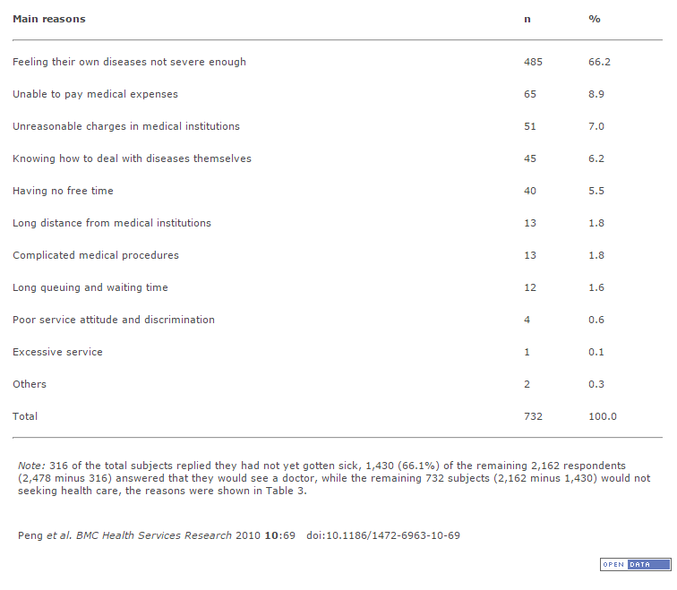

***Table 3***

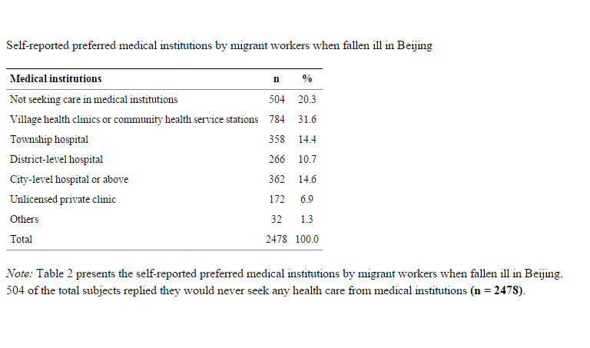

BIBLIOGRAPHY

Anderson, J. G. (1992), Health Care in the People's Republic of China: A Blend of Traditional

and Modern. Central Issues in Anthropology, 10: 67–75. doi: 10.1525/cia.1992.10.1.67

Barber, Sarah L., and Lan Yao. *Health Insurance Systems in China: A Briefing Note*.

Rept. no. 37. N.p.: World Health Orgnaization, 2010. Print.

Beam, Christopher. "Under the Knife." *The New Yorker* 25 Aug. 2014: n. pag. Print.

Bin, Li. "A Chinese Solution to the Global Problem: Progress and Prospect of China’s

Healthcare Reform." Harvard School of Public Health. Boston, MA. 24 Sept. 2014. Lecture.

Briggs, Vernon M., Jr. "Methods of Analysis of Illegal Immigration into the United States."

*Population and Environment* 23.3 (2002): 285-302. Rpt. in *Cornell University ILR*. N.p.: n.p.,

n.d. N. pag. Print.

Chan, K. W. 2013. China: internal migration. The Encyclopedia of Global Human Migration.

*China's Healthcare System - Overview and Quality Improvements*. Stockholm: Swedish Agency

for Growth Policy Analysis, 2013. Print.

"China Statistical Yearbook." N.d. *National Bureau of Statistics of China*. Web. 10 Mar. 2015.

<http://www.stats.gov.cn/tjsj/ndsj/2014/indexeh.htm>.

Chow, Gregory C. *Knowing China*. River Edge: World Scientific, 2004. Print.

Duckett, J. (2001), Political Interests and the Implementation of China’s Urban Health Insurance Reform. Social Policy & Administration, 35: 290–306. doi: 10.1111/1467-9515.00234

Dumoulin-Smith, Adren. *Social Health Insurance in China: An Example of Nascent Social*

*Security in China*. N.p.: Cornell University: Center for the Study of Inequality, 2005. Print.

Eggleston, Karen. "Kan Bing Nan, Kan Bing Gui: Challenges for China's Healthcare

System Thirty Years into Reform." Diss. Stanford U. Print.

Fang, Hai. "Migration, Health Insurance and Health Care Disparities: Evidence from

Hypertension Management in China." Asia Health Policy Program at Stanford University. 7

Nov. 2014. Speech.

Gallagher, E. B. and Subedi, J. (1992), Studying Health Developing Societies: A Conceptually-

Informed Research Agenda. Central Issues in Anthropology, 10: 127–133.

doi: 10.1525/cia.1992.10.1.127

Gamer, Robert E. *Understanding Contemporary China*. 4th ed. Boulder: Lynne Rienner,

2012. Print.

Hesketh, Therese et al. “Health Status and Access to Health Care of Migrant Workers in

China.” *Public Health Reports* 123.2 (2008): 189–197. Print.

"Health Topics: Reproductive Health." *World Health Organization*. World Health Organization,

n.d. Web. 26 Apr. 2015. <http://www.who.int/topics/reproductive_health/en/>.

Hong, Yan et al. “Too Costly To Be Ill: Health Care Access and Health Seeking Behaviors among Rural-to-Urban Migrants in China.” *World health & population*8.2 (2006): 22–34. Print.

Hu, Shanlian. "Measuring and Improving Quality of Care in China: Strengths & Challenges."

Healthcare Reform in China and the U.S: Similarities, Differences and Challenges. Atlanta. 13

Apr. 2011. Print.

Hussain, Athar (January 2003). "Urban Poverty in China: Measurement, Patterns and policies".

*Socio-Economic Security Series*. International Labour Office, Geneva.

Lei, X. and Lin, W. (2009), The New Cooperative Medical Scheme in rural China: does more

coverage mean more service and better health?. Health Econ., 18: S25–S46.

doi: 10.1002/hec.1501

Li, H. et al. “Knowledge, behaviors and prevalence of reproductive tract infections: a descriptive

study on rural women in Hunchun, China,” *Asian Nursing Research*, vol. 4, no. 3, pp. 122–

129, 2010.

Lin, W., Liu, G. G. and Chen, G. (2009), The Urban Resident Basic Medical Insurance: a

landmark reform towards universal coverage in China. Health Econ., 18: S83–S96.

doi: 10.1002/hec.1500

Liu, Hong, Hai Fang, and Zhong Zhao. "Urban-rural Disparities of Child Health and Nutritional

Status in China from 1989 to 2006." *Economics and Human Biology* 11.3 (2013): 294-309.

Print.

Liu, Hong, and Zhong Zhao. *Impact of China's urban resident basic medical insurance on health*

*care utilization and expenditure*. No. 6768. Discussion Paper series, Forschungsinstitut zur

Zukunft der Arbeit, 2012.

Mou, J. et al. *Health care Utilisation amongst Shenzhen migrant workers: Does being insured make a difference?*BMC Health Serv Res. 2009;9:241. doi: 10.1186/1472-6963-9-214.

*National Bureau of Statistics of China*. N.p.: n.p., n.d. *China Statistical Yearbook*. Web. 15 Mar.

2015. <http://www.stats.gov.cn/tjsj/ndsj/2013/indexeh.htm>.

National Health Service. *Guide to the Healthcare System in England including the Statement of*

*NHS* *Accountability*. N.p.: n.p., n.d. Print.

Park, Albert, and Dewen Wang. *Migration and Urban Poverty and Inequality in China*.

Research rept. no. 4877. Bonn: Institute for the Study of Labor, 2010. Print.

Park, Albert. “Rural-Urban Inequality in China.” Prepared for the Eleventh Five-Year Plan of

China. World Bank, Washington, DC., 2004.

Peng *et al.* *BMC Health Services Research* 2010 **10**:69   doi:10.1186/1472-6963-10-69

Qin, Xuezheng, et al., *Too Few Doctors or Too Low Wages? Labor Supply of Health Care Professionals in China.* March 5, 2013. China Economic Review, Vol. 24, No. 1, 2013.

Reid, T.R. *The Healing of America: A Global Quest for Better, Cheaper, and Fairer Health*

*Care*. New York: Penguin, 2011. Print.

Rubalcava, Luis M., et al. "The Healthy Migrant Effect: New Findings From the Mexican

Family Life." *American Journal of Public Health* 98.1 (2008): n. pag. Print.

Shi, Li. *Policy Integration and Statistics Department*. Geneva: International Labour

Organization, 2008. Print. Working Paper 89.

Su, Shu, et al. "Factors associated with utilization of reproductive healthcare services among

migrant women workers in Chong Qing, China." *International Journal of Gynecology &*

*Obstetrics* 127.1 (2014): 66-68.

Taylor, Guy. "China's Floating Migrants: Updates from the 2005 1% Population Sample

Survey." Diss. London School of Economics, 2011. Print.

Yank Cheng, Mark W. Rosenberg, Wuyi Wang, Linsheng Yang and Hairong Li (2012).

Access to residential care in Beijing, China: making the decision to relocate to a

residential care facility. Ageing and Society, 32, pp 1277-1299.

doi:10.1017/S0144686X11000870.

Zhao Y, Kang B, Liu Y, Li Y, Shi G, Shen T. et al. Health insurance coverage and its impact on

medical cost: observations from the floating population in China. PLOS One. 2014;9:e111555.

doi: 10.1371/journal.pone.0111555.